Project Design Phase
Problem – Solution Fit Template
Date | 03 October 2026
Team ID | SWTID-2026-2230
Project Name | Streamlining IT Procurement: Automating  Standard Laptop Orders with Flow Designer
Maximum Marks | 2Marks

Problem – Solution Fit
The proposed solution addresses the difficulties faced by employees, managers, IT administrators, and procurement teams during standard laptop procurement. The ServiceNow Flow Designer automates request validation, approval, procurement task creation, notifications, and order tracking.
Problem / Customer Need | Existing Behaviour | Proposed Solution | Problem–  Solution Fit
Employees need to request laptops easily | Employees may depend on manual requests or communication with IT | Provide a standard laptop request form in ServiceNow | Simplifies laptop request submission
Managers need to approve requests quickly | Approval may require manual communication and follow-up | Automate manager approval through Flow Designer | Reduces approval delays
IT administrators need to validate requests | Request details may be checked manually | Automate validation and laptop availability checks | Reduces  repetitive manual work
Procurement team needs approved  request information | Information may be transferred manually | Automatically create and assign procurement tasks | Improves procurement processing
Employees need status updates | Employees may  repeatedly contact IT for updates | Send automatic notifications when request status changes | Improves transparency
Employees need to track laptop delivery | Order status may not be easily visible | Provide request/order status tracking | Gives better visibility of the  procurement process

Problem → Solution Flow
Manual Laptop Request
↓
ServiceNow Request Form
↓
Automated Validation
↓
Manager Approval
↓
Automatic Procurement Task
↓
Notifications & Order Tracking
↓
Laptop Delivered & Request Completed

Expected Outcome
The solution fits the identified customer problems by providing a faster, simpler, automated, and transparent laptop procurement process. It reduces manual effort while improving request tracking, approval management, communication, and procurement efficiency.

Template
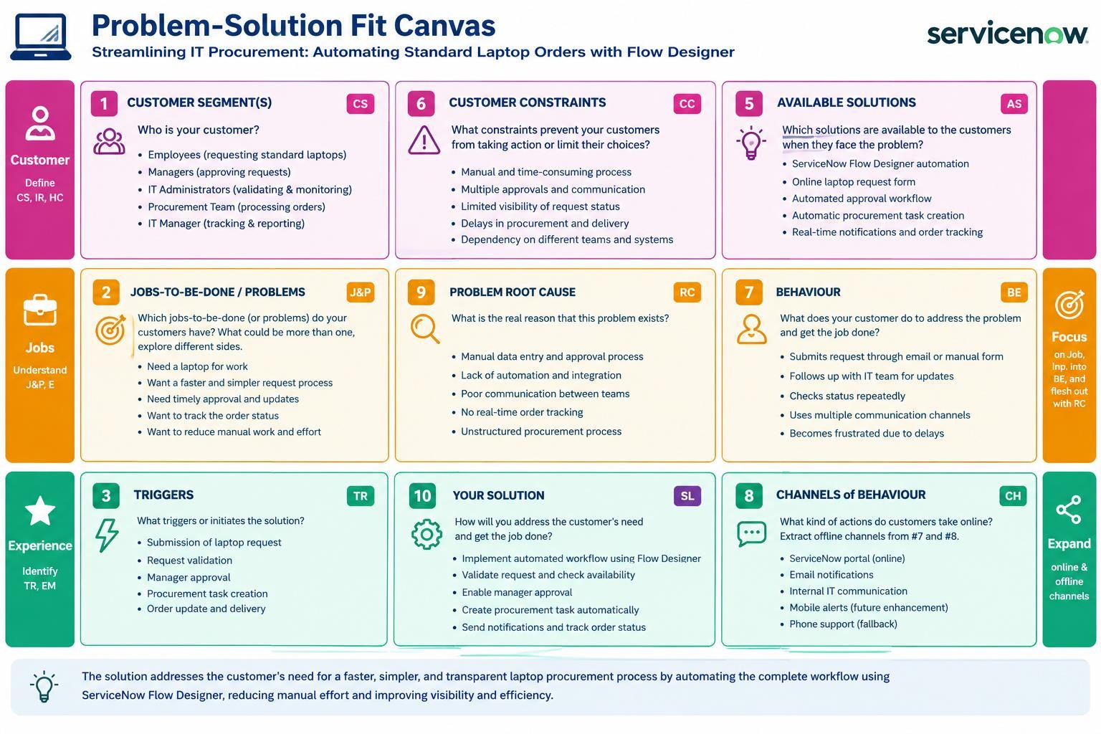
References:
- https://www.ideahackers.network/problem-solution-fit-canvas/
- https://medium.com/@epicantus/problem-solution-fit-canvas-aa3dd59cb4fe

